MGMS – Utilization Reports

Functional Specification Document

Ver. 1.4

Version History
Date | Description
21-Nov-2010 | First Draft

Table of Contents

Introduction

Purpose

This document provides the requirements and functional specifications for the Multisite Grant Management System project.

This is not a project plan or a design document. It is a guide for system architecture and development, not for phasing, timelines or deliverables.

Finally, this is a ‘living document’ and the specification will change, continuously, as the project proceeds. More details will be added and the existing information edited as the requirements, scenarios and use cases evolve in the course of the project.

Scope

Assumptions

Constraints

Submit utilization certificate
In the Projects menu, clicking on a project (line item) in the Search Projects page opens the Project Info page.

On this page, clicking on Reports sub menu (on top in the image below) displays its sub sections (highlighted in yellow) – Utilization Certificates & Submit Utilization Certificate.

Figure 1: Project > Reports Menu
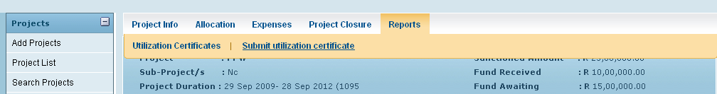

Clicking on Submit Utilization Certificate opens the Create Utilization page as shown below:

Figure 2: Create Utilization
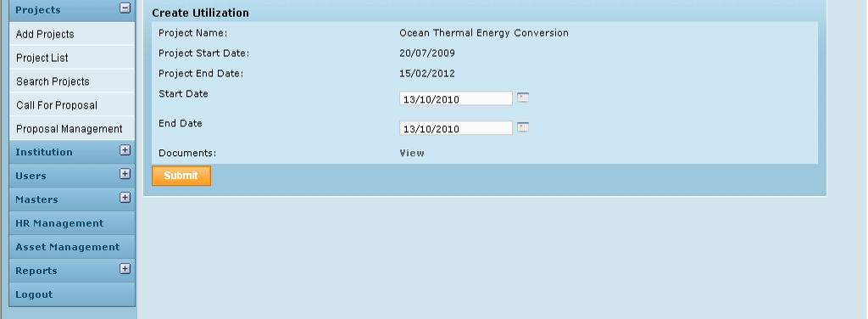

Control Description

Field /Label | Input-Control | Data Type | Remarks
Create Utilization
Project Name: | Auto populated | String
Project Start Date: | Auto populated | Date
Project End Date | Auto populated | Date
Start Date: | Calendar | Date
End Date: | Calendar | Date
Documents |  |  | Link to view Utilization Certificates
View | Button |  | Opens the “Statement of Accounts Reports” window as shown
Submit | Button |  | Refreshes the page as shown below with a message - Utilization certificate submitted

By default, the Start Date is populated with the project start date and End date is populated with the current date.

Figure 3: Create utilization submit - status message
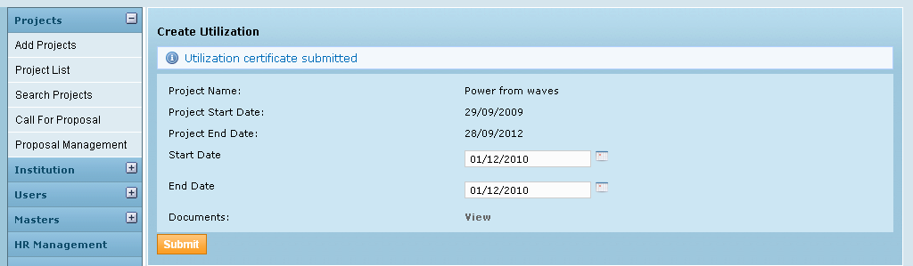

Statement of Accounts Reports

On the screen below, on selecting the start and end date of reporting, the Statement of Accounts and the Utilization Certificate may be opened in PDF format, in 2 separate windows.
The Utilization certificate and Statement of Accounts is specific for each project running at an institution. The utilization certificate is for the year and the Statement of Account calculations are from the project’s start date to the date of generation of report.
The Report Date From is defaulted to Project start date. Report Date To is defaulted to the date that was selected in the Create utilization page.
Figure 4: Statement of Accounts Report
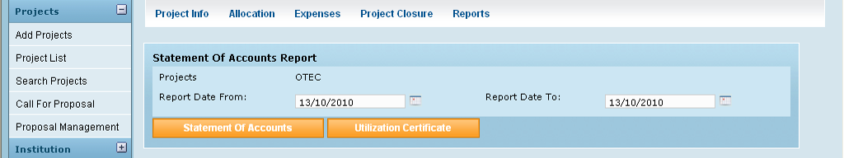

Field /Label | Input-Control | Data Type | Remarks
Statement of Accounts Report
Projects | Auto populated | String
Report Date From: | Calendar | Date | Utilization period (user input)
Report Date To: | Calendar | Date | Utilization period user input)
Statement of Accounts | Button | Opens the corresponding Statement of Accounts in pdf format, in a different window.
Utilization Certificate | Button | Opens the corresponding Utilization Certificate in pdf format in a different window.

Statement of Accounts

The report gives the cash flow in and out of the institution, for a project since its beginning till current date of generation of statement of accounts.

This includes details such as total grant allocated, amount received till now, total expenditure (account head expenses + funds transferred to other institutes as subproject allocations) and finally closing balance

Layout

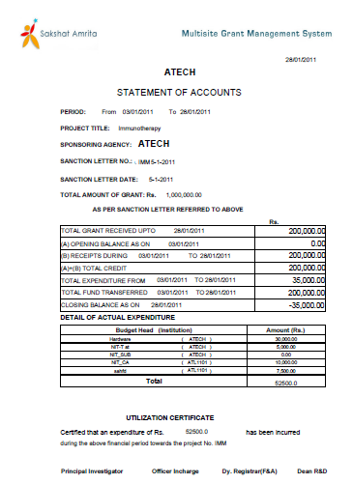
Figure 5: Statement of Account - Report layout

1
2
3
4
5
6
7
8
9
10
11
12
14
15
16
17
13

Data Source

Data Item | Format | Source
<Project Name> | String
Period From | Date
To | Date | current date (date of generating report)
Project Title | String
Sponsoring Agency | String
Sanction Letter No: | String
Sanction Letter Date | Date
Total Amount of Grant | Number | sum of all values of grant_allocation>amount_allocated within the period between project_start_date and current date
1 | Date | current date
2 | Number | sum of all values of grant_receipt>amount within the period between project_start_date and current date
3 | Date
4 | Number | “00.00” (amount in the closing balance as on the date just before report start date.)
5 | Date | project>project_start_date TO current date
6 | Number | sum of all values of grant_receipt>amount
7 | Number | sum of fields 4 & 6 above
8 | Date | project>project_start_date TO current date
9 | Number | sum of fields 13 & 14 (below) i.e sum of all account head expenses and fund transfers.
10 | Date | current date
11 | Number | field 7 – field 9
12 | String | account_heads>name
13 | Number | sum of all values of grant_expense>expense_amount for the particular account head
the row comprising of field 13 – account name and its total expense is repeated for each name of account head associated with the project
14 | Number | sum of all values of fund_transfer>amount
15 | Number | sum of fields 13 & 14 (above) i.e sum of all account head expenses and fund transfers.
16 | Number | same as field 15 above
17 | String | project>code

Utilization Certificates

Layout & Field Description

Layout

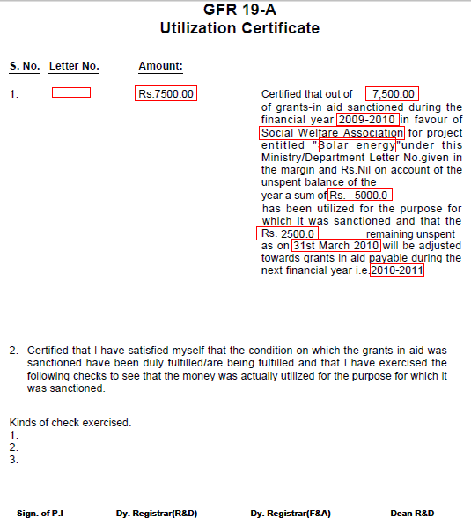
1
2
4
5
3
6
7
8
9
10

Figure 6: Utilization Certificate - Layout

Data Source

Data Item | Format | Source
1 | String | grant_receipt>reference_id
2 | Number | sum of all values of grant_receipt>amount received with in the period of the given report start/end dates
3 | String | party>name_of_the_institution
4 | Number | sum of all values of grant_receipt>amount received with in the period of the given report start/end dates
5 | String | grant_period>name
6 | String | project>name
7 | Number | sum of all values of grant_expense>expense_amount within the period of the given report start/end dates
8 | Number | Difference between the values in fields 4 & 7 (above)
9 | Date | last date of the current grant period
10 | String | value of the next grant period for this project (grant_period>name)

Grouped by project name and name of the institution

Assumptions:

Business Rules
Utilization certificate – start date should always be the project start date.
Once a utilization report has been generated for a certain period, a user will not be allowed to enter expenses within that period for that project. Alert message will explain the reason.
Currently it is ok for a grantee’s report to give sub grantee’s utilization even though sub grantee has not submitted its report
Currently it is ok that at all times utilization certificate and statement of account are generated and submitted together
Currently Expense can be entered only after allocation made to the particular account head but it is not necessary to have received sufficient funds.
But expenses should not go beyond the allocation

Utilization formula =
Scenario: A grants project to B who sub allocates part of it to C. Sub allocation ends there
So C submits a certificate to B, and B submits a certificate to A.

Utilization certificate generated by C will add up all expenses which happened at C towards the particular project
Utilization certificate generated by B will add up all expenses which happened at B as well as at C, towards the particular project. This is because C is a direct sub project of B. So a grantee’s utilization certificate should include the expenses incurred at sub grantee level also.

Statement of Accounts

Statement of accounts is strictly for the institution which generated the report.
For a given project, report start date and report end date

Sl No | Line Item | Description
1 | TOTAL GRANT RECEIVED UPTO <date> | sum of funds received by the institution till <report end date>
2 | (A) OPENING BALANCE AS ON <date> | closing balance as on the date just before <report start date>
3 | (B) RECEIPTS DURING <date> TO <date> | sum of funds received by the institution between <report start date> and <report end date>
4 | (A)+(B) TOTAL CREDIT | sum of above 2 items
5 | TOTAL EXPENDITURE FROM <date> TO <date> | sum of all expenses incurred by the institution between <report start date> and <report end date>
6 | TOTAL FUNDS TRANSFERRED FROM <date> TO <date> | sum of all funds transferred from the institution between <report start date> and <report end date>
7 | CLOSING BALANCE AS ON <date> | (4) – [(5)+(6)] as on <report end date>

DETAIL OF ACTUAL EXPENDITURE - format
Here expense details of own as well as sub projects are listed.

Serial No: | Account Head | Amount (Rs.)
 | <account head1> - <own institution>
 | <account head2> - <own institution>
 | <account head1> - <grantee>
 | <account head3> - <grantee>
 | Total

Status Messages

Sl No | Status Message
1
2
3
4

